***Psychology 7.1 (2014)***

***Credulity: Science, Pseudoscience, and Thinking Critically about Human Behavior***

***Mon, Wed, Fri, 11:15-12:20am***

***X-hour: Tuesday, 12:00-12:50pm***

Clipart - ufo. fotosearch 
- search clipart, 
illustration posters, 
drawings and vector 
eps graphics images

[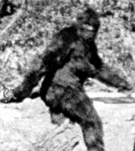](http://www.cryptozoology.com/cryptids/images/sasquatch01.jpg)

Why do you believe what you believe?

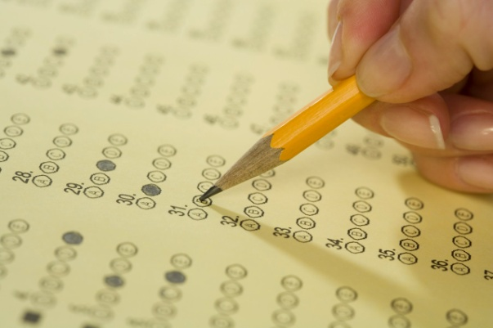

***Are people who feel they have been abducted by aliens any different from those who do not?***

***Does Bigfoot exist?***

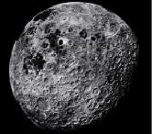

***Do people really act “crazy” during a full moon?***

***Is it really better to go with your “first hunch” when taking a multiple choice test?***



***Can you tell if someone is staring at you without actually seeing them?***

*What is this course about?*

You can learn new information, like a language, while asleep. A handshake can tell you something about a person’s personality. You only use 10% of your brain. Opposites attract.[[1]](#footnote-1) People believe in all kinds of things about human behavior without ever questioning *why* they believe in such things. This course is intended to examine some common myths in psychology and in the world around you and give you some of the tool to answer the question, “Why do people believe in weird things?”

*What are the learning objectives for this class?*

By the end of the class, I hope students will be able to:

* Establish your personal criteria for belief in new, traditional, and unusual ideas.
* Think critically about ideas inside and outside of the field of psychology and never take for granted that something someone says is true unless you are provided with evidence.
* Discuss their skepticism about an idea or belief with respect and intelligence to those who might hold such ideas or beliefs in high regard.

*What will we be reading?*

* Harrison, G. (2012). 50 Popular Beliefs that People Think are True. Prometheus.
* Lilienfeld, S.C., Lynn, S.J., Ruscio, Beyerstein, B.L. (2010). 50 Great myths of popular psychology. Wiley-Blackwell.
* Tavris, C. (2011). Psychobabble and Biobunk (3rd ed.). Pearson.

C:\Documents and Settings\John_F_Pfister\Local Settings\Temporary Internet Files\Content.IE5\N1H2X549\MC900044963[1].wmf

*How do I contact the instructor?*

***Extraordinary claims require extraordinary evidence.***

***--David Hume***

I always have office hours (347 Moore Hall) M: 2-3pm, W: 2-4pm Th: 10-noon, 4-5pm, but I’ll do my best to accommodate your schedule and meet you anytime the both of us are free. The best part of this course for me is talking to students, but I can be a little hard to reach at times. I wear many hats on campus and at home and the occasional emergency will crop up that will need my attention.

*How can I get to know the professor and my classmates a little better?*

Half the fun of a First-Year seminar is talking about it beyond the four walls of the classroom. So, I routinely carry on the conversation from class whenever I bump into a student in a dining hall or along the sidewalk.

I routinely have lunch on campus on Wednesdays and I would love it if you would join me. If you prefer ’53 Commons, or the Hop, or even a cheap bowl of soup at Umpleby’s downtown, let’s make it a point of occasionally having an informal meal together and get to know each other outside of the classroom.

*What will the class be like from day-to-day?*

Participants will be required to complete the assigned readings for each day of class. **Each student should be prepared to lead a “mini-discussion” by preparing questions or observations before the class meeting.** Classes will be supplemented by additional readings (as they are both appropriate and available), films, and other activities. Because this format depends upon participation, absences will not be allowed without excuse. If you miss more than two classes, I reserve the right to withhold your **entire** participation grade.

In the last weeks of the course, you will be able to host a discussion and presentation on the results of your research into a pseudoscientific claim or psychological myth. You can get help from me or from the RWIT on the preparation of your presentation, but don’t be afraid to ask the class to read or reread something for class or supplement your presentation with a video or demonstration.

A DECLARATION

It should be stated at this point that there is a world of difference between being a skeptic, being a cynic, and even, being a jerk. This course is an attempt to foster a healthy attitude when evaluating the veracity of the many claims you will encounter regarding human behavior. You should find this course an oasis for your opinions and beliefs. I hope you will always feel comfortable expressing your opinion and tolerant during discourse with others. As you will hear me say many times, “I don’t care whether you believe in UFO’s or not; I just want you to understand *why* you believe in them.”

*Will we have to use our x-hour?*

Our x-hour (T: 12:00-12:50pm) will be used routinely for a classroom activity or some really weird film. PLEASE keep x-hours on your calendars and attend them with the same dedication you would dedicate to regular class periods.

*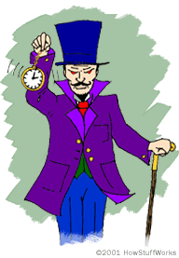What will I be required to do other than come to class?*

This course will have a series of EIGHT writing assignments (anywhere from 1 to 4 pages) of which you will do SIX[[2]](#footnote-2), a “myth-busting” presentation of a topic of your choice and, of course, class participation. Each week, we will end the Friday class with a series of potential writing assignments (discussed in class) and spend the weekend putting together a document for the following Friday. Here’s how the editing works for this course: I will work with any draft of your paper as long as it is handed in by 4pm on Tuesday. If you submit a draft version you are eligible to have your final draft resubmitted for re-grading if you are unhappy with the final result. If you do not submit a draft by Tuesday, you do not have the option of asking for a re-grade. You may also access this option by asking for a peer review (more on this later…). Drafts are returned by Friday at the latest and the final version is handed in on Wednesday of the following week.

AN OBLIGATION

What can you say about plagiarism and academic dishonesty that you don’t already know? Copying the words of other researchers or students without appropriate referencing or claiming someone’s work as your own is plagiarism. Very specific guidelines exist for the creation of original work and citations of other’s work can be seen at <http://www.dartmouth.edu/~sources/>. We will take great pains to talk about this in class, but should you have a question and need guidance, I would rather you delay handing something in than risk your academic career. No late penalty is worth a suspension.

*How will I be graded?*

Your final grade will be based upon four separate elements

ESSAYS[[3]](#footnote-3)………………………60%

PRESENTATION………………15%

CLASS CONTRIBUTIONS…...15%

PEER EDITING……….……….10%

I know, of course, that I can never really relieve you of the burden of worrying about grades, but if your work is handed in on time, you try your best with the writing exercises, and contributions to in class discussions, you will not only do well in this course, but will come to look forward to getting together every week.

*What happens if I turn in an assignment late?*

First the good news; you are hereby granted one (1), Monday-Friday extension for any one assignment you have due this term (REQUST MUST BE 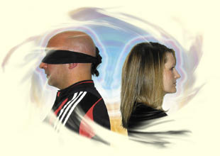SUBMITTED IN WRITING). Use it wisely! Now, the bad news; other than this one extension, any other late submission will result in a full letter grade (that is, from an A to a B) reduction for every 24 hours (the weekend counts for 1 late day). No paper receiving more than two reductions will be accepted. The only exception to this policy is an officially documented College excuse (health or family emergency). No, you do not need a dean’s verification. Let’s just be honest with one another.

*Be your own teaching assistant!*

I have always loved the writing portion of this course. I have seen some terrific ideas put forth and the occasional story that I have just had to tell my colleagues about. But, I am always a little disappointed when a student asks me, “Well, what do you want us to write?” To move beyond the “write-for-the-professor” I am asking you to help me with some of the rough drafts of your colleagues. Each week two or three students will be selected to receive a pair of papers to read and comment upon. These papers will be from anonymous authors and you will be expected to comment upon, suggest changes, and meet with me to talk about the papers in detail. This meeting will occur sometime between Wednesday morning and Friday afternoon. If you are lucky, we can do over a lunch or a breakfast and get to know one another a little better.

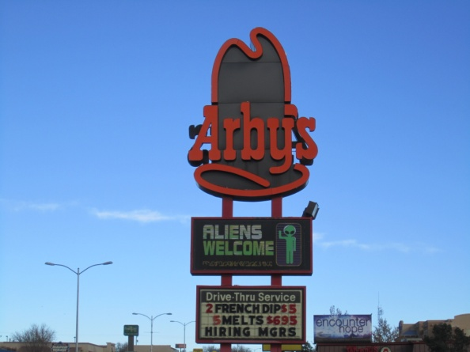

*What if I have a documented disability that interferes with my performance in class?*

Any student with a documented disability need academic adjustments or accommodations is invited and encouraged to speak with me by the end of the second week of the term (January 21). All discussions will remain confidential, although the Academic Skills Center will be consulted to verify the documentation of the disability.

*Anything else I should know about this course?*

I always look forward to teaching this course and it is important to me that you feel like you are getting something out of the discussions and readings. I also hope you have a little fun. Should at anytime during the term you feel like you would like to take the course in a

different direction or want to try something a little different, do not hesitate to ask. I want to learn as much as you do and a good class dialogue goes in both directions.

AN INVITATION

Come visit my office library from time to time to find something interesting to read. You’ll find the beginnings of a “skeptic’s library” with such titles as, Alien Contacts & Abductions: The Real Story, The Faith Healers, and Nibbling on Einstein’s Brain. It’s worth a stop by just to go through the video library alone!

In lieu of a personal visit, have a look at some websites that may get you thinking like a skeptic: <http://skepdic.com/> (home of the Skeptic’s Dictionary...an excellent source), [www.skeptic.com](http://www.skeptic.com) (home of the Skeptics Society Web Page), [www.junkscience.com](http://www.junkscience.com) (a little more about scientific flaws, but neat, nonetheless), and [www.quackwatch.com](http://www.quackwatch.com) (medical fraud). Don’t forget the great journal, The Skeptical Inquirer and the companion site, <http://www.csicop.org/si/online.html>. This is a spectacular resource and I urge you to look at some of the original articles here and think about them as a source for your writing. Check out everything from articles on pet psychics (<http://www.csicop.org/si/2002-11/pet-psychic.html>) to how NOT to test claims of communication with the afterlife (<http://www.csicop.org/si/2003-01/medium.html>). A fairly complete set of original copies are available in my office in Moore Hall.

Tentative Schedule

Week One: Introductions and getting started

|  |  |  |
| --- | --- | --- |
| Date | *What we will be doing* | *What you should be reading* |
| January 6 | **Introducing the course and discussing expectations on the part of both the instructor and student** |  |
| January 7 (X-hour) | **FILM: THE SECRET OF THE PSYCHICS** |  |
| January 8 | **The wide, wide world of psycho-mythology. Do we only use 10% of our brains?** | Lilienfeld, et.al.: Introduction, Chapter 1; Higbee, K.L. and Clay, S.L. (1998). College students’ beliefs in the ten-percent myth. *Journal of Psychology, 132: 469-476.* (BB)[[4]](#footnote-4) |
| January 10 | **Magical Thinking. (Assignment #1 goes out.)** | Harrison, Myths 1-8. |

Week Two: Thinking about how the media portrays myths (both good and bad)

|  |  |  |
| --- | --- | --- |
| Date | *What we will be doing* | *What you should be reading* |
| January 13 | **What is the Mozart effect? Is there such a thing as a midlife crisis?** | Lilienfeld, et.al.: Chapters 2 & 3. Tavris (TBA). |
| January 14 (X-hour) | **PENN AND TELLER’S “BULLSHIT” (Rough draft of Assignment #1 is due by 4pm).** |  |
| January 15 | **If you are unsure of your answer when taking a test, is it better to stick with your original hunch? Will you REALLY bark like a dog under hypnosis?** | Lilienfeld, et.al.: Chapters 4 and 5. Tavris (TBA). |
| January 17 | **Science and Reasoning/Strange Healings (Assignment #2 goes out.)** | Harrison, Myths 16-27. |

Week Three: Some really strange things people think are true

|  |  |  |
| --- | --- | --- |
| Date | *What we will be doing* | *What you should be reading* |
| January 20 | **MLK DAY (No classes held.)** |  |
| January 21 (X-hour) | **FILM: FACILITATED COMMUNICATION (Rough draft of Assignment #2 is due by 4pm).** |  |
| January 22 | **Do lie detectors detect anything at all? Do opposites attract? (The final draft of Assignment #1 is collected.) Can your handwriting really tell you anything about a person’s personality?** | Lilienfeld, et.al.: Chapters 6, 7, 8 and 9. Tavris (TBA). |
| January 24 | **Lure of the Gods. Does religion belong in these discussions? (Assignment #3 goes out.)** | Harrison, Myths 28-39. |

Week Four: Finally, we get to talk about alien abduction!

|  |  |  |
| --- | --- | --- |
| Date | *What we will be doing* | *What you should be reading* |
| January 27 | **Just how naïve are people about mental illness? Is Lillienfeld being too naïve? (The final draft of Assignment #2 is collected.)** | Lilienfeld, et.al.: Chapters 10 and 11. Tavris (TBA). |
| January 28 (X-hour) | **FILM: ALIEN ABDUCTION (Rough draft of Assignment #3 is due by 4pm).** |  |
| January 29 | **Out there** | Harrison, Myths 10-14. |
| January 31 | **So, is there anything in psychology that is NOT a myth? (Assignment #4 goes out.)** | Lilienfeld, et.al.: Postscript. Tavris (TBA). |

Week Five: Let’s do an experiment!

|  |  |  |
| --- | --- | --- |
| Date | *What we will be doing* | *What you should be reading* |
| February 3 | **Can you sense when someone is staring at you? (The final draft of Assignment #3 is collected.)** | Tavris (TBA).Sheldrake (BB): Intro, Chapters 8 and 11 |
| February 4 (X-hour) | **FILM: TBA (Rough draft of Assignment #4 is due by 4pm).** |  |
| February 5 | **Can you sense when someone is staring at you?** | Tavris (TBA).Sheldrake (BB): Intro, Chapters 8 and 11 |
| February 7 | **CARNIVAL HOLIDAY …NO CLASSES. BE SAFE! (Assignment #5 goes out.)** |  |

Week Six: Ghosts, witches and things that go bump in the night…Oh, and the end of the world!

|  |  |  |
| --- | --- | --- |
| Date | *What we will be doing* | *What you should be reading* |
| February 10 | **Bizarre beings. (The final draft of Assignment #4 is collected.)** | Harrison, Myths 40-43. |
| February 11 (X-hour) | **FILM: TBA (Rough draft of Assignment #5 is due by 4pm).** |  |
| February 12 | **Weird places/Dreaming of the end.** | Harrison, Myths 44-50. |
| February 14 | **Catch up, interesting ideas and things we did not get to explore: (urban legends, Dartmouth myths, dowsing, faith healing, homeopathy, graphology, etc.) (The final draft of Assignment #5 is collected.)** | TBA |

Week Seven: Now, the class is yours!

|  |  |  |
| --- | --- | --- |
| Date | *What we will be doing* | *What you should be reading* |
| February 17 | **Catch up, interesting ideas and things we did not get to explore: (urban legends, Dartmouth myths, dowsing, faith healing, homeopathy, graphology, etc.) (The final draft of Assignment #5 is collected.)** | TBA |
| February 18 (X-hour) | **FILM: TBA (Rough draft of Assignment #6 is due by 4pm).** |  |
| February 19 | **STUDENT MYTHBUSTING PRESENTATIONS** | TBA (Presenter’s choice) |
| February 21 | **STUDENT MYTHBUSTING PRESENTATIONS (Assignment #7 goes out.)** | TBA (Presenter’s choice) |

Week Eight: A second week of presentations

|  |  |  |
| --- | --- | --- |
| Date | *What we will be doing* | *What you should be reading* |
| February 24 | **STUDENT MYTHBUSTING PRESENTATIONS (The final draft of Assignment #6 is collected.)** | TBA (Presenter’s choice) |
| February 25 (X-hour) | **FILM: TBA (Rough draft of Assignment #7 is due by 4pm).** |  |
| February 26 | **STUDENT MYTHBUSTING PRESENTATIONS** | TBA (Presenter’s choice) |
| February 28 | **STUDENT MYTHBUSTING PRESENTATIONS (Assignment #8 goes out.)[[5]](#footnote-5)** | TBA (Presenter’s choice) |

Week One: The last week of classes!

|  |  |  |
| --- | --- | --- |
| Date | *What we will be doing* | *What you should be reading* |
| March 3 | **STUDENT MYTHBUSTING PRESENTATIONS (The final draft of Assignment #7 is collected.)** | TBA (Presenter’s choice) |
| March 4 (X-hour) | **FILM: TBA (Rough draft of Assignment #8 is due by 4pm).** |  |
| March 5 | **STUDENT MYTHBUSTING PRESENTATIONS** | TBA (Presenter’s choice) |
| March 7 | **STUDENT MYTHBUSTING PRESENTATIONS** | TBA (Presenter’s choice) |

**THERE IS NO FINAL EXAM FOR THIS COURSE!**

*This course is dedicated to my mother.*

*You always taught me that curiosity was a virtue*

*And never failed to keep me from asking, “Why?”*

1. One of these statements is actually considered true. Can you guess which one? [↑](#footnote-ref-1)
2. I reserve the right to make one of these assignments MANDATORY. This will likely come up in the middle of the term as we explore scientific citations and how to use them. [↑](#footnote-ref-2)
3. You only have to do 6 out of the 8 essays, but if you choose to do more, the grades for the all of the essays you do will be averaged together. [↑](#footnote-ref-3)
4. Occasionally I like to add a reference from a journal or other source to supplement the reading. I have placed these readings on CANVAS and designated them with the letters (CAN). I never mean to overwhelm you with readings, but you can feel free to tell me to cut back and spare you from reading just for reading’s sake. [↑](#footnote-ref-4)
5. The final draft of Assignment #8 will be due by 4pm on March 10. [↑](#footnote-ref-5)